Uganda

## Population Data

The data set shows the political stability estimate of the country each year.

## # A tibble: 23 x 5  
## country iso3c date population popCategory5  
## <chr> <chr> <dbl> <dbl> <chr>   
## 1 Uganda UGA 1996 21032821 small   
## 2 Uganda UGA 1997 21655398 small   
## 3 Uganda UGA 1998 22290780 small   
## 4 Uganda UGA 1999 22952410 small   
## 5 Uganda UGA 2000 23650172 small   
## 6 Uganda UGA 2001 24388968 small   
## 7 Uganda UGA 2002 25167257 medium   
## 8 Uganda UGA 2003 25980552 medium   
## 9 Uganda UGA 2004 26821297 medium   
## 10 Uganda UGA 2005 27684585 medium   
## 11 Uganda UGA 2006 28571475 medium   
## 12 Uganda UGA 2007 29486338 medium   
## 13 Uganda UGA 2008 30431736 medium   
## 14 Uganda UGA 2009 31411096 medium   
## 15 Uganda UGA 2010 32428167 medium   
## 16 Uganda UGA 2011 33476919 medium   
## 17 Uganda UGA 2012 34559168 medium   
## 18 Uganda UGA 2013 35695246 medium   
## 19 Uganda UGA 2014 36912148 medium   
## 20 Uganda UGA 2015 38225453 medium   
## 21 Uganda UGA 2016 39647506 medium   
## 22 Uganda UGA 2017 41162465 medium   
## 23 Uganda UGA 2018 42723139 medium

# Population growth data

## # A tibble: 23 x 5  
## country iso3c date popGrowth popGrowthCat5   
## <chr> <chr> <dbl> <dbl> <chr>   
## 1 Uganda UGA 1996 2.99 high growth rate  
## 2 Uganda UGA 1997 2.92 high growth rate  
## 3 Uganda UGA 1998 2.89 high growth rate  
## 4 Uganda UGA 1999 2.92 high growth rate  
## 5 Uganda UGA 2000 2.99 high growth rate  
## 6 Uganda UGA 2001 3.08 high growth rate  
## 7 Uganda UGA 2002 3.14 high growth rate  
## 8 Uganda UGA 2003 3.18 high growth rate  
## 9 Uganda UGA 2004 3.18 high growth rate  
## 10 Uganda UGA 2005 3.17 high growth rate  
## 11 Uganda UGA 2006 3.15 high growth rate  
## 12 Uganda UGA 2007 3.15 high growth rate  
## 13 Uganda UGA 2008 3.16 high growth rate  
## 14 Uganda UGA 2009 3.17 high growth rate  
## 15 Uganda UGA 2010 3.19 high growth rate  
## 16 Uganda UGA 2011 3.18 high growth rate  
## 17 Uganda UGA 2012 3.18 high growth rate  
## 18 Uganda UGA 2013 3.23 high growth rate  
## 19 Uganda UGA 2014 3.35 high growth rate  
## 20 Uganda UGA 2015 3.50 high growth rate  
## 21 Uganda UGA 2016 3.65 high growth rate  
## 22 Uganda UGA 2017 3.75 high growth rate  
## 23 Uganda UGA 2018 3.72 high growth rate

## Population trend

The plot shows the population trend of the country.

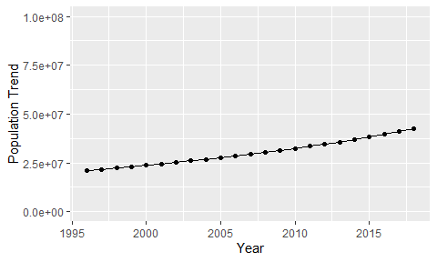

Political Stability Trend

# Population growth trend

The plot shows the population growth rate trend of the country.

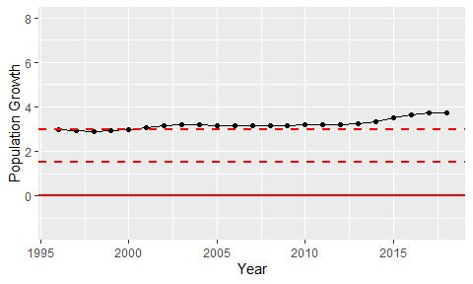

Population Growth Trend